April 22, 2025
As the XBI suffers, Q1 shows a few comforting signs of underlying stability

The XBI has plunged 27% since Donald Trump won the election, leaving the public markets an ugly mess for a biotech industry yearning for better times. Talk to CEOs these days and the mood for many is bleak — with worries about what the impact of tariffs and trade wars will have on the economy, adding some bitter seasoning to a stew of anxiety over a reorganization of the FDA and the abrupt mass exit of staffers under a controversial HHS chief whose skeptical views on vaccines skew to quackery.

Trump’s recent attacks on Fed chief Jerome Powell have only further destabilized a market unsettled by daily social media posts from the White House.

Chris Dokomajilar
But it may amaze you to find out that it’s not all bad news for the first few months of the year. If you narrow the focus, a close look at the charts Chris Dokomajilar at DealForma posted for Q1 shows that several of the most-watched biotech numbers nevertheless continued to hang steady. That’s the silver lining to some troubling trends — though these numbers don’t include the turbulence we’ve witnessed in April.

The bottom line: IPOs remain in the doldrums, with PIPEs and follow-ons continuing to struggle after a much more bullish Q1 in 2024 inspired short-lived hopes. But dealmaking activity remains consistent, Phase 2 assets are drawing some sizable payouts, and a fluctuating M&A scene held up in a period of reduced expectations — compared to the fondly remembered Covid boom.

One big new trend you cannot ignore: Despite all the combative remarks between Chinese and US officials, Big Pharma is increasingly turning to Chinese biotechs for clinical-stage drugs.

The big question now is how things will hold up in Q2, at a time uncertainty is killing hopes for a near-term recovery of biotech.

Chart 1: Dealmaking activity stays strong — thanks to services pacts
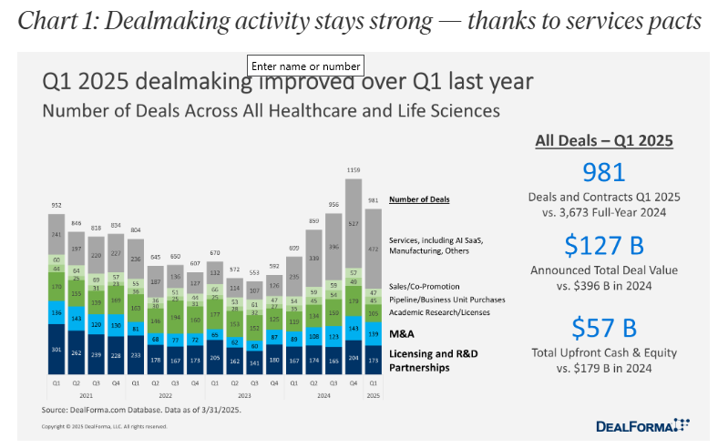

Dealmaking activity slid somewhat compared to the big spike we saw in the last three months of 2024, but the number of deals was up significantly over Q1 2024 and registered as the second-highest quarterly performance compared to the past four years.

AI SaaS and other service deals surged last year and remained strong in Q1, which is the primary reason why dealmaking has continued on a strong pace at the start of 2025. And it bodes well for continued work in AI, as industry players hustle to avoid being left behind of that big trend.

Just looking at the number of deals, M&A and licensing/R&D partnerships also held steady in the first quarter, with some fluctuations.

Chart 2: VC numbers are steady
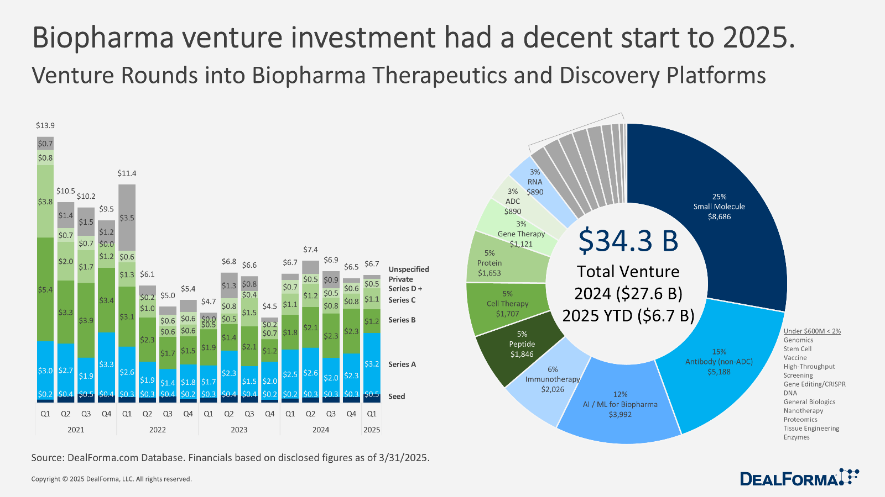

VC activity was steady for Q1 2025, compared to the same quarter a year ago, with the venture class focusing much of their money and attention on Phase 1.

The venture numbers fall very much in line with what we tracked through last year, with $6.7 billion in total for Q1 compared to $27.6 billion in all of last year. The Q1 total also matched the performance of Q1 2024, though it all pales in comparison to the quarterly numbers driving a much more enthusiastic 2021.

Breaking out the pie chart on where the full $34.3 billion through last year went, and you’ll see the biggest piece going to small molecules (25%) with non-ADC antibodies at 15% and AI/ML coming in at a close third with 12%.

Chart 3: IPOs are (still) out
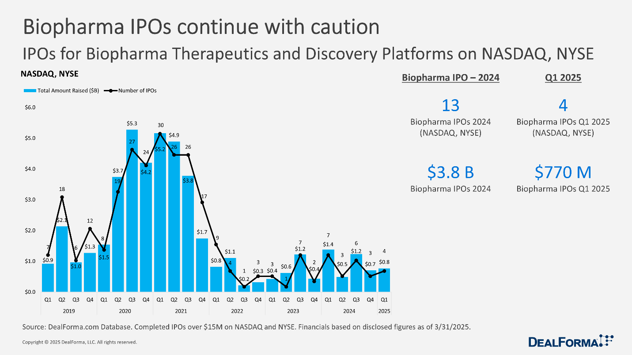

IPOs remain in the doldrums, which will be a surprise to no one with the slightest interest in biotech.

The whole IPO field went cold after a torrid 2020 and the first half of 2021, and has been stuttering along ever since, periodically jumping enough to kindle hopes for a return of generalist investors, only to see the numbers dwindle again as deals go under water.

It doesn’t help that a slew of biotechs are now trading for less than cash. And the experience of the new IPOs leaves a lot to be desired. Aardvark Therapeutics went public at $16 a share in February and has since lost close to half of that value. With examples like that scattered around like wrecked cars on the speedway, it’s no surprise to see biotechs hanging on to their S-1s.

As the public markets skittered in and out of bear territory, with tariffs inspiring fears of slow growth and higher prices and a mood of general uncertainty that has generalists looking for a financially secure port in the storm, Q2 is not looking like the time for a rebound.

Chart 4: PIPEs and follow-ons hit the skids
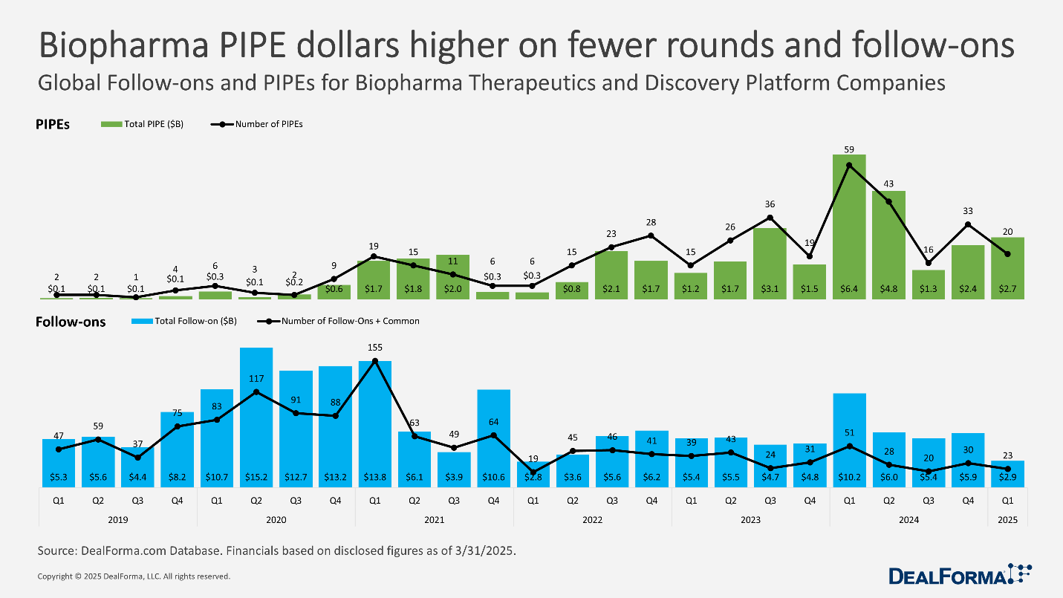

Back at the start of 2024, one of the bright spots for biotech could be seen in the surge of new PIPEs and follow-ons that raised serious money for public companies.

But the encouraging trend barely survived the first half of last year.

In the first three months of 2025, the number of PIPEs dropped significantly, though the total raised edged up somewhat compared to Q4 2024. A meager 23 follow-ons raised only $2.9 billion in Q1 of this year, less than a third of what was gathered in the same quarter a year ago.

Chart 5: J&J juices the M&A numbers for Q1
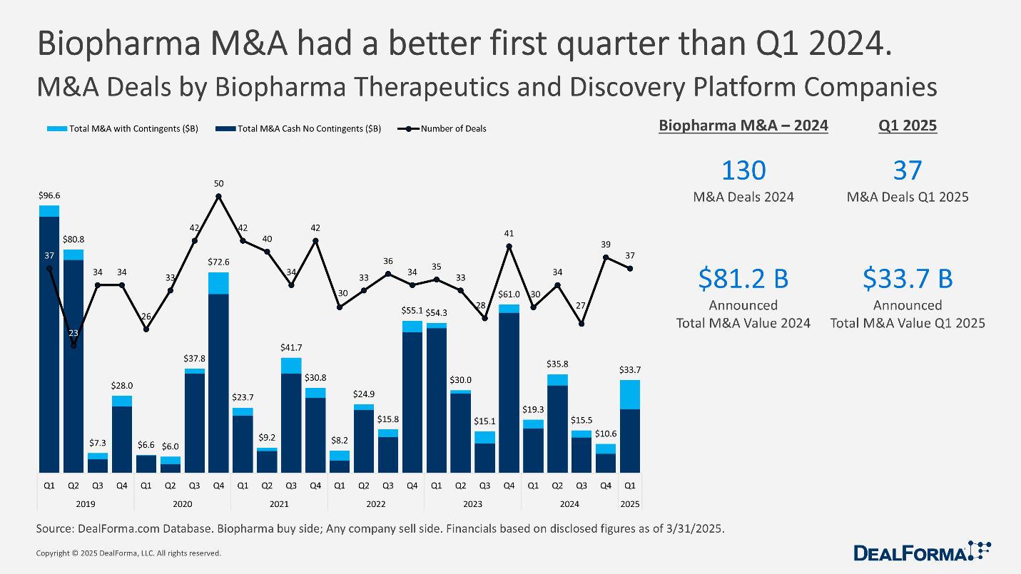

M&A, which tends to fluctuate quarter to quarter, outperformed some meager numbers posted a year ago.

Back in January, J&J got the M&A ball rolling with its $14.6 billion deal to acquire Intra-Cellular Therapies. That one deal accounted for a big chunk of the $33.7 billion in M&A DealForma tracked in Q1.

That is much better than the $19.3 billion charted for the same period a year ago, as 2024 got off to a slow start on a field that has proven quite a disappointment in biopharma.

Back at JPM, I made the bold prediction that we’d see a couple more deals over $10 billion by the end of the year. Right now, that’s looking like a long shot, at best. But it’s early yet.

Chart 6: 2025 licensing pacts get off to a solid start
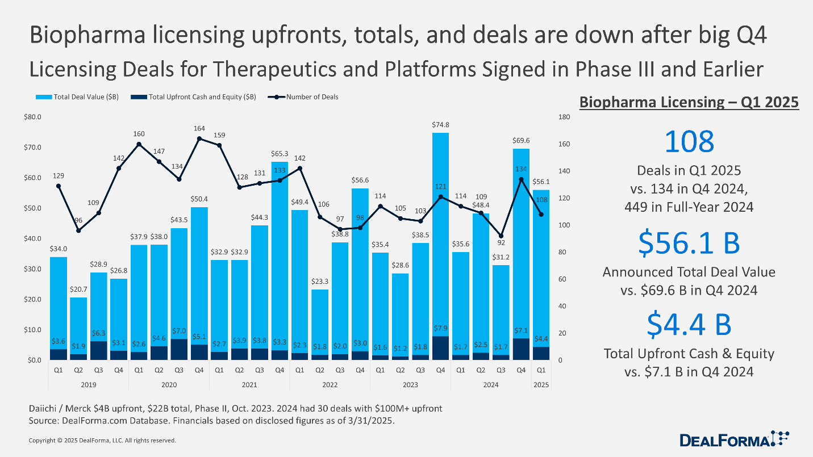

Biopharma licensing pacts also slid down from a surge at the end of 2024, though the numbers looked better than a year ago for the same period.

The $4.4 billion shelled out in upfront cash for therapeutics and platforms in Q1 this year registered a sharp drop from the $7.1 billion on the table in Q4 of last year, but it was still significantly higher than a weak $1.7 billion start to 2024.

Add in the biobucks and the Q1 tally comes in at $56.1 billion, compared to $35.6 billion for the same period a year ago.

Look out over a few years and you’ll see that Q4 often ends on a high note, so perhaps a solid start indicates better performance for the months ahead. This year, though, will likely be notoriously difficult to predict.

Chart 7: Chinese biotechs quickly muscled their way to the top of the dealmaking chain
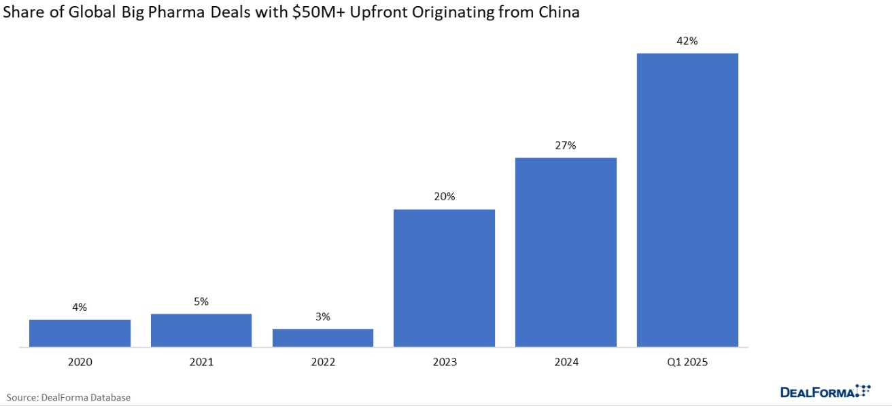

After claiming only a small, marginal number of deals with $50 million-plus upfront in 2022, the number of these deals originating from China — Chinese biotechs licensing to global partners — has rapidly swelled to 42% of the global share for these large pacts in Q1 2025, according to DealForma.

The sudden emergence of Chinese biotechs as a source of major new drug programs has clearly shaken the biotech industry, presenting a rival to US biotechs which had grown accustomed to dominating this arena.

Now China’s reputation for speed in clinical trials, along with an increasingly innovative approach to drug development, has the potential to blindside companies that had thought they had a clear shot at holding on to best-in-class, first-in-class boasting rights. And it’s all happening as trade tensions between the US and China reach extremes few could have predicted.

Chart 8: Big Pharma doubles down on Phase 2
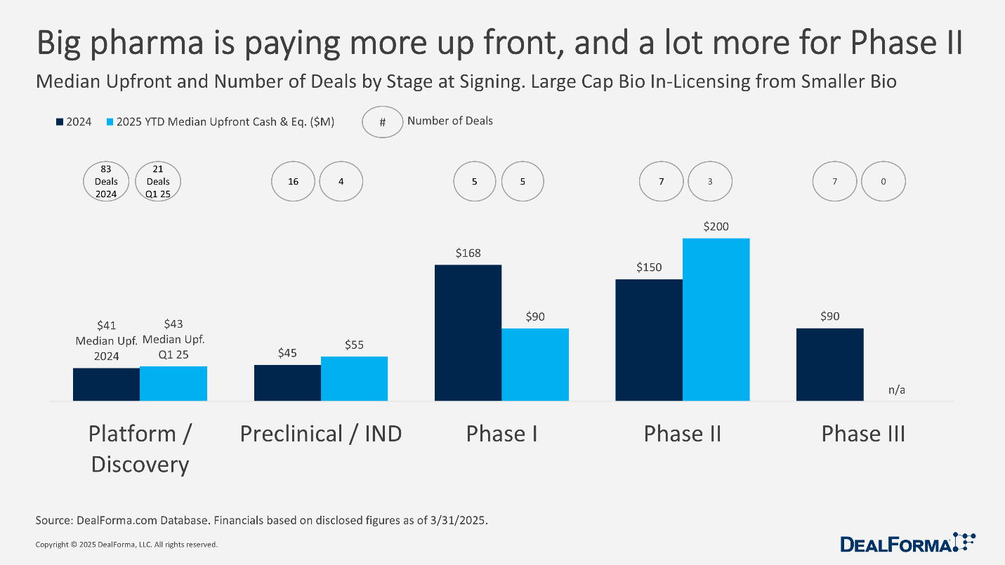

The surge in China deals comes as large-cap companies have proven willing to pay out more for the drugs roped in from the smaller biotechs, with Phase 2 assets performing particularly well.

YTD the median of upfront cash and equity from Big Pharmas for Phase 2 drugs has hit $200 million, compared to $150 million for all of 2024. Phase 1 has dipped — from $168 million to $90 million — though Q1 2025 has no Phase 3 deals to compare with last year’s track record.

Right now, the bright and shining allure of discovery-stage drugs can’t compare to hard human data on drugs poised to go into pivotal trials.

Chart 9: ADC deals settle in at a slow pace
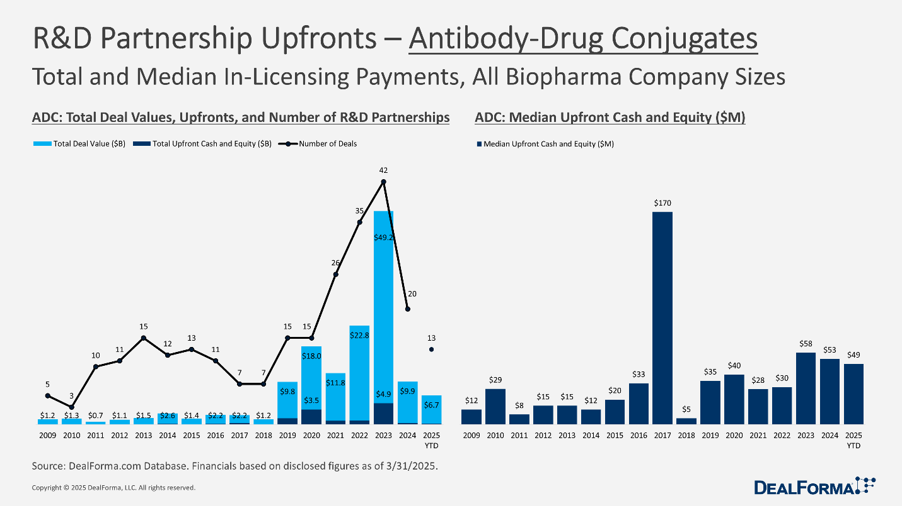

ADC deals have been doing a fast fade, perhaps underscoring that the best partnerships have been identified and struck, Dokomajilar notes.

Back in 2023, ADCs were all the rage. But while 2025 got off to a promising start — compared to all of 2024 — it’s unlikely to come close to that earlier, torrid pace.

